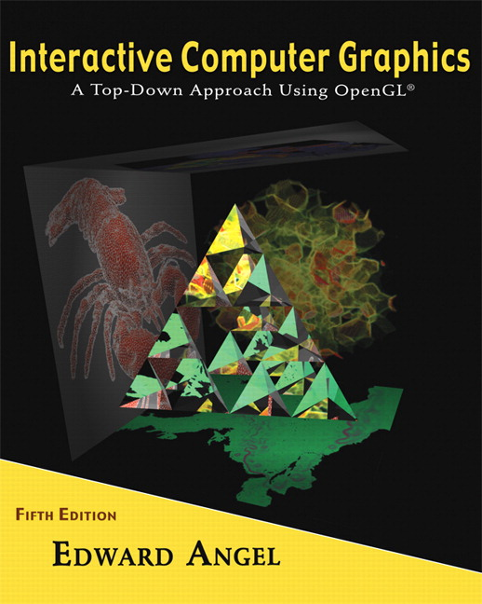

Name: ______________________ Terminal # ____

Programming Assignment 3
(100 points)

The Programming Assignment is to be turned in the first ten minutes of the due date class as:

Hardcopy (with your terminal #!)
Source Code and screenshots that shows that your Visual Studio 2010 “Programming Assignment 3” PROJECT compiles and runs!

Electronic: Submit the Visual Studio2010 “Programming Assignment 3” zipped PROJECT to BB so you can run it in 200 PGH!

“Humanoid - Summer 2011” Color & Shading and Texturing Instructions
(The file “Humanoid Summer 2011.pdf” contains the specifications for the humanoid.)

1. The glutCreateWindow OpenGL call will take as parameter “YourLastName Humanoid Version 3”.
2. Start with the MyHumanoid.c that you have created in Programming Assignment 2 and call the file LastNameHumanoid.c.

3. Lighting and Shading:
Add 1 spot light initially located on the base inside the humanoid torso on the front left, distance term a = 1, initial direction towards the center of the humanoid head. You can use the coefficients from the Lecture 6 and the format from Homework 6 for the MaterialStruct.
You should allow the movement of the light source in 3 positions on each x and z axis, i.e., front left, middle, right and side left front, middle, and back.
You should allow three changes of the angle of the light, top, middle, bottom.

4. Texturing:
Texture your humanoid by using either a texture similar to the actual humanoid or any other humanoid siding textures or bump mapping.
If you have several texturing, create a menu to use all of them. I guess this could be the extra credit problem. (10 points)

5. Navigating:
First, the discrete reposition & orientation of the light should be linked to a menu , key, etc.
Second, the LookAt needs to be amended with the following camera positions:

- at the opening looking toward the middle back humanoid, back right top corner, back top left corner.
- in the middle of the humanoid looking at the same as above PLUS back towards the front opening.
Attach these fixed positions to a menu, key, etc.

Get screenshots of the “YourLastName Humanoid Version 3” for each view and please comment on what the screenshot is about.

